40KHD

Douglas Gromek

Geoffrey Kitchner

Dragons and Dungeons in the Dark

Requirements Document



Introduction: (GK)

The purpose of this document is to encapsulate the functions and requirements of the *Dragons and Dungeons in the Dark* application. Within these pages are the detailed descriptions of the functions and the utilities offered to the player. The *Description Model* will lay out the requirements of the system. It describes the specific actions of each object in the application. The *Class Diagram* will display all of the objects, attributes and known methods in the system. It will clarify the methods available to the player through the objects present in the application. The *Use Case Diagram* will examine all possible uses of the system. The diagram will display the relationship between the separate functions of the application and the player. The *Use Case Scenarios* will sketch all activity events and the exceptions possible with them. It will dissect the specific interactions between the player and the application. The *Systems Sequence Charts* will provide further detail on each *Use Case Scenario*. Thecharts will show the specific data sent between the player and the application

Description Model: (DG)

**Initial Requirements**

Dragons and Dungeons in the Dark is an application designed to be a supplemental aid for RPG (role playing game) players. As such, the majority of its features are designed to work offline. Regardless of Internet connectivity, the player will be able to use every feature of the application except for the share character option. This increases the situations in which the player will be able to take advantage of our app, as well as decreases expected data charges and battery drain. The share character option is a supplemental function of the app and is not necessary for the player to get full use out of the app.

**Security**

No login or customer information is stored within the application. All information entered by the user is assumed to be fictional in nature and has zero security risk if a breach occurred. If the player chooses to share their character information to social media, their login information will all be handled solely through the 3rd party social media sites. All data being sent to social media websites will be protected only to the minimums required by those websites. Interaction between the app and the phone consists solely of the character save slots which hold a simple database storing all character information. Programming best practices will be used to ensure device integrity is not compromised by the app.

**Processes**

Title and Main Menu:

After launching the app, the player will see a title screen displaying the application’s name and logo, which will be displayed until loading has finished. The player will then be automatically brought to the main menu. First time players will then have to choose to either “Create New Character” or “Create New Random Character”. Each option will have its own button located below the save slots. There will be three slots fields on the screen. Each slot will display empty if it has no character saved there. If there is a save present, the date and time of the last time it was opened will be shown in the slot. After selecting their choice, along with a save slot, the player will then go through the process of creating their new character. Also available on the login screen will be the option to share their character to social media. This is accomplished by selecting the “Share Character” button. The final button on the main menu will be the “quit” button which closes the application.

Create New Character:

The player is able to choose this feature by selecting the “Create New Character” button located in the main menu. After clicking this button, the user will then be asked to choose an available save slot in order to create their character. If all save slots are filled, a message will inform the user that there is no open slot, and ask the player if they want to overwrite an existing character. The player will then have the option to either continue and create a new character in a used save slot, or quit back to the main menu. Once a save slot has been selected, the player will be presented with the character trait page where they will be required to manually fill in their character’s name, race, class, alignment, and background. After selecting “finished”, the player will be brought to the character stat page where a built-in dice rolling function will automatically calculate the character’s strength, dexterity, constitution, intelligence, wisdom, and charisma. The dice roll results will be automatically presented to the user, with no animation or sound effects. After selecting “Continue onto Items”, the player will be presented with the item and armor generation page where the built-in dice rolling function will automatically calculate the character’s items and armor. The player will then be shown the generated items. The player then will select the “Finished” button and be presented with the option to either “Quit Without Saving”, “Save and Quit”, or “Save and Continue”. If the player selects the third option, their character will be saved and they will be automatically brought to the main character sheet.

Create Random Character

If the player selects the “Create Random Character” button on the main menu, a new character will be created without any input from the player. The process follows the exact same steps as the “Create New Character” option, except everything will happen invisibly without player input. After confirming a save slot to create the new character, the app will automatically generate all character traits, stats, items and armor. The player will then be shown a summary page showing everything that was just generated. The same three save/quit options as in the “Create Random Character” process will then be presented to the player.

Character sheet

The Character Sheet acts as the main screen that will be displayed throughout the game. It can be accessed immediately after a new character has been created, or if a character has been created previously, by selecting the save slot for that character from the main menu. The character sheet is broken down into four main sections. This includes character stats, items, equipment, and level. The center of the screen displays all the character information that the player will be able to change as the game progresses. To change any of these values, the player selects the value and a text box appears that allows for manual entry of numbers. The very top of the screen displays the static character information. This includes the name, race, class, alignment, and background. Underneath the character information are three tabs that allow the player to access the rulebook, comment sheet, and dice roller. Clicking any of these tabs opens up a new window overlaid over the character sheet. In the top left of the screen will be a menu button. Selecting this will open up a drop-down menu that lets the player select a settings option, save their character, or quit the game.

Roll Dice

The roll dice option will be accessed by clicking on the “Roll” tab located below the character information. Selecting this option opens up a separate, overlaid window. Within this window will be a textbox allowing the user to enter the number of dice they would like to roll (between one and twenty dice). There will be another text box below the first one that allows the user to select how many sides the dice they are rolling will have (between two and one hundred). To the right of both of these textboxes will be an image that updates to display a visual depiction of how many dice/how many sides the user has selected. Attempting to enter invalid numbers into either of this fields will result in an error message, and the field will reset back to blank. Once the player has entered valid numbers, they will be able to select a “Roll Dice” button which then calculates a random roll(s). The results of the individual dice rolls, as well as the sum, min, and max will be displayed in the window. The player will then be able to re-roll, enter new numbers and re-roll, or quit rolling and close the menu. The last used number of dice and sides will be saved when the roll menu is closed. Upon reopening the roll tab, the text fields for both the dice number and dice sides will be automatically populated with the previous settings.

Comments Sheet

The comments sheet will be accessed by clicking on the “Comments” tab located below the character information. Selecting this opens up a separate, overlaid window. The comment sheet will start as a blank window that functions exactly like a notepad. The player will be able to click anywhere within the sheet and add text. The player will also be able to delete any text that they have added. Clicking anywhere within the sheet will automatically bring up the phones virtual keyboard. When the player is done adding text, they can click the “finished” button at the bottom of the sheet. The current state of the comment sheet will then be saved and the overlaid window will be closed, returning the player to the character sheet. Each comment sheet is unique to the save slot and only one sheet is allowed per character.

Rulebook

The rulebook is accessed by clicking on the “Rulebook” tab located below the character information. Selecting this opens up a separate, overlaid window. The rulebook is an exact text copy of the current version of the official Dungeons and Dragons® rules. Once the rulebook window is open, the player will be able to use a scroll bar to traverse the document. A search button will be located at the bottom of the rulebook window that allows the player to more quickly navigate the rules. Once the player clicks this button, an empty text field will be displayed on the top, right of the comment sheet. The player can click on this field and enter any text. The player will then be told how many occurrences of their search item appears in the rules. Small up/down arrows located right next to the search box will allow the player to jump between occurrences of their search criteria. If no results are found, a “No Results” error message will be displayed. The rulebook is not able to be edited in anyway by the player. Once the player is done, they can click the “Finished Search” button to close the search text field. The player can click the “Close Rulebook” button at any time in order to close the rules window and return to the character sheet. The current rulebook page will be stored when it is closed, and will automatically be displayed when the rulebook is next opened.

Character Sharing

The player can share their character to social media by using the “Share Character” button located on the main menu. After clicking, the player will be asked to choose a valid save slot. If all save slots are currently empty. An error message “No valid save slots” will be presented to the user, and they will be returned to the main menu. In order to share their character, the player must have a linked social media account. The player will select the social media site they would like to share to, and then be asked to sign-in to their account (all sign-in information and processes are handled by external links provided by the social media website API’s. At no point will the application interact with this data).

There are two share options the user can choose between.

1. “Share Full Game State”: Create a document which compiles all static and dynamic character information. This option also includes the user’s comments, and all roll-conditions and results
2. “Share Character State”: Create a document which compiles all static and dynamic character information.

After the character has been shared, the user will be presented with a “Share Successful” message, and automatically be returned to the main menu.

Save Slots

Besides the initial download and storage of the application, the character save slots are the only interaction between the application and the phone’s internal storage. The player can choose to save their character while they have the character sheet open. Clicking on the drop down “menu” button in the top left corner of the character sheet displays the “Settings”, “Save Character”, and “Quit” options. Selecting save character prompts the player to choose between either “Save and Continue” or “Save and Quit”. Regardless of which option is selected, the player will be asked to choose a valid save slot. An empty save slot, or a save slot with a character already in it can be chosen. The player will then have to confirm that they want to overwrite the save slot. After confirming, the current state of the character will be saved. This state includes data from the character sheet, comments tab, roll settings, game settings, and rulebook page. The same steps will occur if the player chooses the “save and quit” option. If that option has been chosen, the player will be returned to the main menu. On the main menu, a delete option will be presented next to each save slot that the player can use if they want to delete a previous character.

Customizable Settings

The game settings can be changed while the character sheet is open. The settings are accessed by clicking on the drop down “Menu” button located on the top left of the character sheet. Clicking on the “Settings” option opens up a single, overlaid window that displays all game settings. From here, the player can change three settings. Sound can be toggled “On”/”Off” using check boxes. Dark mode can be toggled “On”/”Off” with check boxes. When dark mode is off, the application will have a light screen with black text. When dark mode is on, the application will have a dark screen with white text. The final setting is themes that can be applied to the character sheet. All theme options are shown in a drop-down box. Any change to the settings will be immediately applied to the game. The player next selects a “finished” button. The settings will then be saved and the window will be closed, returning the player to the character sheet.

Class Diagram: (GK)

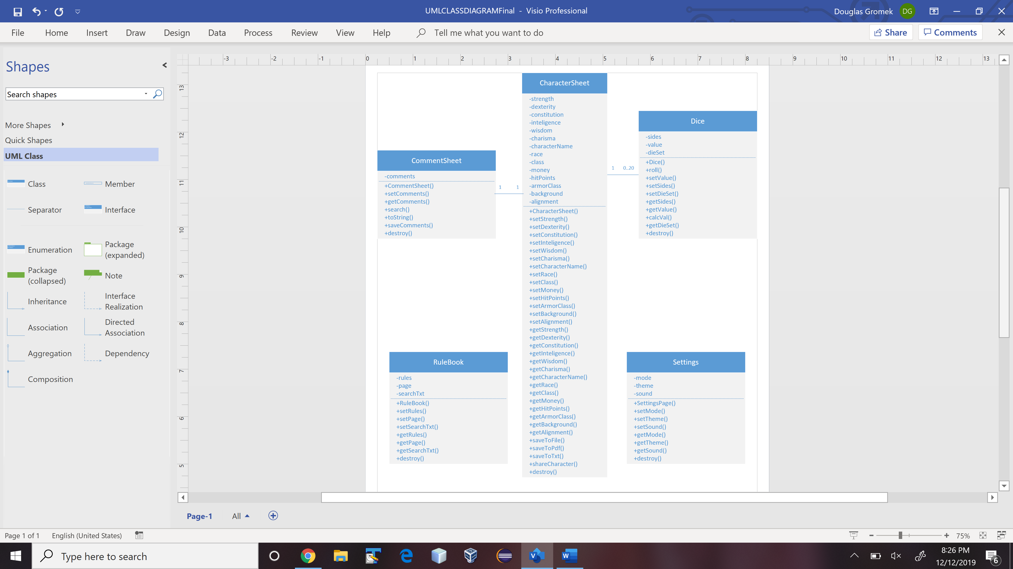

Use Case Diagram: (GK)

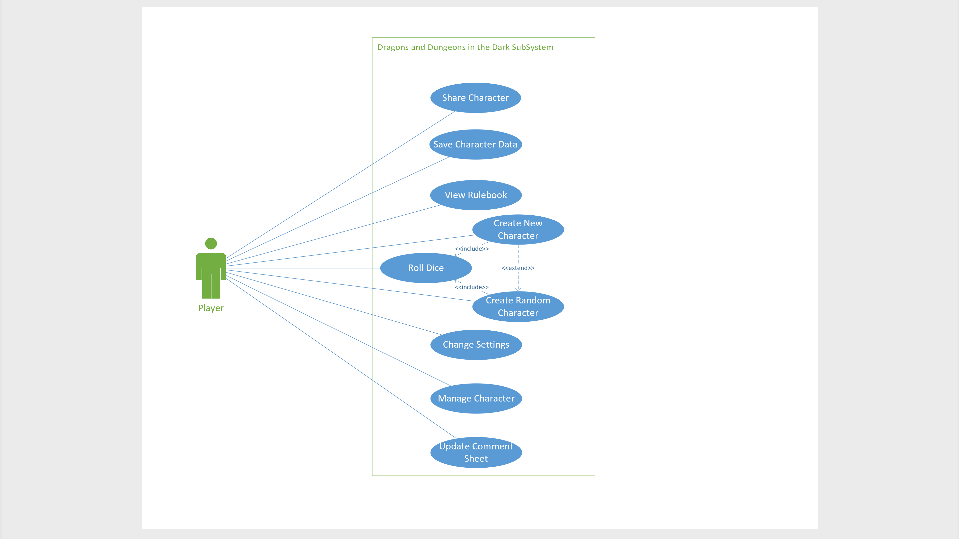

Use Case Scenarios: (DG)

|  |  |  |
| --- | --- | --- |
| **Use Case Name:** | Create New Character | |
| **Scenario:** | A new player-character is created | |
| **Triggering Event:** | The player wants to create a new character to be used in a game of D&D | |
| **Brief Description:** | If the player wishes to create a new in-game character, they have the option of creating a character with stats based on dice rolls, while still being in control of choosing certain details about the character | |
| **Actors:** | Player | |
| **System:** | Main | |
| **Related Use Cases:** | Create Random Character | |
| **Stakeholders:** | NA | |
| **Pre-conditions:** | There must be an available save slot | |
| **Post-condition:** | A new character has been created and saved; main character sheet displayed | |
| **Flow of Activities:** | **Actor System** | |
| **1** | Player opens app/returns to main menu |  |
| **2** | Player selects “create new character” button | Display main character details page |
| **3** | Player chooses character name, race, class, alignment, and background |  |
| **4** | Player selects “finished” | Display character stats page |
| **5** | Player selects “roll for stats” | Perform (6) random dice rolls |
| **6** |  | Display calculated stats (strength, dexterity, constitution, intelligence, wisdom, charisma) |
| **7** | Player selects “continue onto items” | Display items page |
| **8** |  | Generate 1-5 pieces of random armor |
| **9** |  | Display generated armor |
| **10** | Player selects “finished” | Display save character page |
| **11** | Player selects “save and begin game” | Display main character sheet |
| **Exception Conditions:** |  | |
|  | 2. No free save slots available  a. “create new character button” is hidden  4.1 Player selects “finished” before they choose all traits  a. display error message  4.2 Player selects the “cancel” button  a. return to the main menu  5, 7, 9. Player selects the “return” button  a. return to previous page  10. Player selects “save and quit”  a. save character  b. Return to main menu  10. Player selects “quit without saving”  a. Return to main menu | |

|  |  |  |
| --- | --- | --- |
| **Use Case Name:** | Create Random Character | |
| **Scenario:** | Create a fully randomly generated character without any player input | |
| **Triggering Event:** | Player wishes to not make any choices when creating a character | |
| **Brief Description:** | If the player wishes to create a new in-game character, they have the option of generating a character without any needed input. Any entire character is generated with the single click of a button. | |
| **Actors:** | Player | |
| **System:** | Main | |
| **Related Use Cases:** | Create New Character | |
| **Stakeholders:** | NA | |
| **Pre-conditions:** | There must be an available save slot | |
| **Post-condition:** | A new player character is created and saved; main character sheet displayed | |
| **Flow of Activities:** | **Actor System** | |
| **1** | Player opens app/returns to main menu |  |
| **2** | Player selects “create random character button” | Display confirmation screen |
| **3** | Player selects “continue” | Display “creating character” page |
| **4** |  | Perform random dice rolls |
| **5** |  | Generate character traits (name, race, class, alignment, background) |
| **6** |  | Generate character stats (strength, dexterity, constitution, intelligence, wisdom, charisma) |
| **7** |  | Generate 1-5 pieces of character armor |
| **8** |  | Display “character created” page |
| **9** | User selects “save and begin game” | Display main character sheet |
| **Exception Conditions:** |  | |
|  | 2. No free save slots available  a. “create new character button” is hidden  3. User selects the “cancel” button  a. return to the main menu  8. User selects “save and quit” button  a. save character  b. return to main menu  8. User selects “quit without saving” button  a. return to main menu | |

|  |  |  |
| --- | --- | --- |
| **Use Case Name:** | Roll Dice | |
| **Scenario:** | Roll dice during in-game events | |
| **Triggering Event:** | Player needs to roll dice due to in-game events | |
| **Brief Description:** | Before or after certain in-game events, the player will need to select a varying number of different types of dice and roll them. | |
| **Actors:** | Player | |
| **System:** | Main | |
| **Related Use Cases:** | Create New Character, Create Random Character | |
| **Stakeholders:** | NA | |
| **Pre-conditions:** | A character sheet is currently open | |
| **Post-condition:** | Display roll results (individual dice, sum, min, max), save last dice configuration | |
| **Flow of Activities:** | **Actor System** | |
| **1** | Player selects “Roll Dice” tab | Display roll dice tab |
| **2** | Player enters the number of dice into text-field |  |
| **3** | Player enters the number of dice sides in text-field | Display dice image |
| **4** | Player selects “Roll Dice” button | Calculate roll results (individual, sum, min, max) |
| **5** |  | Display roll results |
| **6** | Player selects the “return” button | Save current dice setting |
| **7** |  | Return to main character sheet |
| **Exception Conditions:** |  |  |
|  | 2, 3, 4. Player selects the return button   1. Save current dice settings 2. Return to main character page   2. Player enters a number greater than 20  a. Display error message  b. Clear text-field  3. Player enters a number greater than 100  a. Display error message  b. Clear text-field  6. Player selects the “Roll Dice” button  a. Calculate roll results  b. Display roll results | |

|  |  |  |
| --- | --- | --- |
| **Use Case Name:** | Save Character Data | |
| **Scenario:** | Save current game state | |
| **Triggering Event:** | Player wishes to save character mid-game or upon quitting | |
| **Brief Description:** | At any point during a game, the player can access a save button located in the drop down menu that will save the current game state to a chosen save slot. | |
| **Actors:** | Player | |
| **System:** | Main | |
| **Related Use Cases:** | NA | |
| **Stakeholders:** | NA | |
| **Pre-conditions:** | A character sheet is currently open | |
| **Post-condition:** | A new copy of the game state has been added to the phone | |
| **Flow of Activities:** | **Actor System** | |
| **1** | Player selects the “menu” tab | Display menu options |
| **2** | Player selects the “save character” button | Display save options |
| **3** | Player selects “save and continue” button | Display save slots to player |
| **4** | Player selects a save slot | Display “overwrite save slot?” |
| **5** | Player selects “confirm overwrite” | Save character to save slot |
| **6** |  | Return to character sheet |
| **Exception Conditions:** | 2. Player selects the “return” button  a. close menu tab  3.1 Player selects “cancel” button  a. close save options  3.2 Player selects “save and quit”  a. display save slots  b. user selects save slot  c. save game state  d. return to main menu  4. Player selects the “return” button  a. return to save slots menu  5. Player selects “cancel”  a. return to save slots menu | |

|  |  |  |
| --- | --- | --- |
| **Use Case Name:** | Share Character | |
| **Scenario:** | Player uploads the current game state to social media | |
| **Triggering Event:** | Player clicks the “share character” button | |
| **Brief Description:** | After a character has been created, a player may upload a compiled document of it to social media. The player has the option to choose which social media platform they would like to share to. The player also has an option to upload the full game state, or just the character information. | |
| **Actors:** | Player | |
| **System:** | Main, External | |
| **Related Use Cases:** | NA | |
| **Stakeholders:** | NA | |
| **Pre-conditions:** | Player must have a saved game state | |
| **Post-condition:** | The current game state has been shared to a social media platform | |
| **Flow of Activities:** | **Actor System** | |
| **1** | Player starts app or returns to main menu |  |
| **2** | Player selects “share character” button | Display save slot selection menu |
| **3** | Player selects a single save slot |  |
| **4** | Player selects “continue” button | Display “share character options” menu |
| **5** | Player selects “share full game-state” |  |
| **5** | Player selects “share character information” |  |
| **6** |  | Display social media options menu (Facebook, Instagram, Twitter) |
| **7** | Player picks any number of social media platforms |  |
| **8** | Player selects “share now” | Create character share information page by pulling from save slot |
| **9** |  | Export character information to social media |
| **10** |  | Return to main menu |
| **Exception Conditions:** | 2. Player does not have a used save slot  a. display error message to user  b. return to main menu  4. Player selects “cancel” button  a. return to main menu  5. Player selects “cancel” button  a. return to main menu  8.1 Player does not have any linked social media accounts  a. ask user to link social media accounts or press “cancel” to  return to main menu  8.2 Player does not have internet access  a. display error message to user, return to social media options menu | |

|  |  |  |
| --- | --- | --- |
| **Use Case Name:** | View Rulebook | |
| **Scenario:** | Player looks up rules during the game | |
| **Triggering Event:** | Player selects the rules option inside the menu tab | |
| **Brief Description:** | At many points throughout the game, the player will need to look up various rules in the official D&D handbook. This rule book will be stored as an offline, searchable, text document stored within the app that the player can access anytime. | |
| **Actors:** | Player | |
| **System:** | Main | |
| **Related Use Cases:** | NA | |
| **Stakeholders:** | NA | |
| **Pre-conditions:** | Player has a created character and has the character sheet open | |
| **Post-condition:** | Player finishes looking up rules and returns to character sheet | |
| **Flow of Activities:** | **Actor System** | |
| **1** | Player selects the “menu” button | Display menu options |
| **2** | Player selects “rulebook” option | Overlay text rule book over the character sheet |
| **3** | Player scrolls through rulebook using sidebar |  |
| **3** | Player enters text into the search bar | Search rulebook for occurrences of text |
| **4** |  | Display “results” box showing number of occurrences and arrows allowing user to jump between results. Highlight found results. |
| **5** | Player uses arrows to find the rule they were looking for | Scroll through rulebook |
| **6** | Player selects the “finished” button | Display text rule book without search parameters |
| **7** | Player selects the “close rulebook option” | Close rulebook overlay, returning control to character sheet |
| **Exception Conditions:** | 3.1 Player selects “close rulebook”  a. return to character sheet  3.2 No results found for searched text  a. Display message informing user of zero search results  6. Player enters another text to search for  a. Return to System Step #3  7. Player enters another text to search for  a. Return to System Step #3 | |

|  |  |  |
| --- | --- | --- |
| **Use Case Name:** | Change Settings | |
| **Scenario:** | Player changes various in-game settings | |
| **Triggering Event:** | Player selects the settings option inside the menu tab | |
| **Brief Description:** | At any point during a game, the player can change game settings including: sound effects, dark mode, and character sheet themes. These settings are controlled by check boxes and drop-down menu options all within a single display window | |
| **Actors:** | Player | |
| **System:** | Main | |
| **Related Use Cases:** | NA | |
| **Stakeholders:** | NA | |
| **Pre-conditions:** | Player has a created character and has the character sheet open | |
| **Post-condition:** | Changes made to in-game settings. New settings saved | |
| **Flow of Activities:** | **Actor System** | |
| **1** | Player selects the menu button | Display menu options |
| **2** | Player selects the settings button | Display a single window with options for: Sound, Dark mode, and character page themes. |
| **3** | Player makes changes to settings | Update settings options |
| **4** |  | Implement in-game changes |
| **5** |  | Save current settings |
| **6** | Player selects the “finished” button | Return to character sheet |
| **Exception Conditions:** | 2. Player selects the “cancel” button  a. close menu options  b. return to character sheet  3. Player only has a basic account instead of a premium account  a. character page theme options are greyed out  b. character page theme options are not selectable | |

|  |  |  |
| --- | --- | --- |
| **Use Case Name:** | Comment Sheet | |
| **Scenario:** | Player adds or removes text comments from comment sheet | |
| **Triggering Event:** | Player wishes to make changes to comment sheet | |
| **Brief Description:** | During a game, the player will want to keep track of events and character information that is not accounted for within the standard character sheet options. The player will instead be given a comment sheet where they can add/remove text at any point throughout the game | |
| **Actors:** | Player | |
| **System:** | Main | |
| **Related Use Cases:** | NA | |
| **Stakeholders:** | NA | |
| **Pre-conditions:** | Player has a created character and has the character sheet open | |
| **Post-condition:** | Changes have been made to the player’s comment sheet | |
| **Flow of Activities:** | **Actor System** | |
| **1** | Player selects on the “comment sheet” tab | Display comment sheet overlaid over character sheet |
| **2** | Player clicks where they would like to add text or remove text | Bring text cursor to selected point |
| **2** |  | Display virtual keyboard |
| **3** | Player adds or removes text | Update comment sheet to display new state |
| **4** | Player selects the “finished” button | Save comment sheet |
| **5** |  | Close comment sheet and return control to character sheet |
| **Exception Conditions:** | 1. Another menu, sheet, or tab is currently open or overlaid  overtop of the character sheet  a. player is unable to select character information  b. player “error beep” audio  2,3. Player selects the “finished” button  a. save comment sheet  b. close comment sheet, return control to character sheet | |

|  |  |  |
| --- | --- | --- |
| **Use Case Name:** | Manage Character | |
| **Scenario:** | Player changes character information | |
| **Triggering Event:** | Player selects changeable character data on character sheet | |
| **Brief Description:** | During a game, the player will need to make changes to all information displayed within the character sheet, including: Stats, character level, armor, items, spells, and traits. | |
| **Actors:** | Player | |
| **System:** | Main | |
| **Related Use Cases:** | NA | |
| **Stakeholders:** | NA | |
| **Pre-conditions:** | Player has a created character and has the character sheet open | |
| **Post-condition:** | Changes have been made to the character information | |
| **Flow of Activities:** | **Actor System** | |
| **1** | Player selects on the character information they would like to change | Display editable text field next to data player wishes to change. |
| **2** | Player makes changes to character info | Change selected character info |
| **3** |  | Update other character info that is reliant on what is being changed |
| **4** | Player selects the “finished” button | Save changes to active save slot |
| **5** |  | Return to character sheet |
| **Exception Conditions:** | 1. Another menu, sheet, or tab is currently open or overlaid  overtop of the character sheet  a. player is unable to select character information  b. player “error beep” audio  2. Player selects the “finished” button without making changes  a. Return to character sheet without changes  b. do not save current game state  2. Player enters invalid text  a. display error message  b. Return character information to previous value | |

System Sequence Charts: (DG)



